The Child Care Counts Coalition is dedicated to stabilizing and increasing the number of available slots for high quality child care in Windham County. Recognizing that access to child care is a critical economic and workforce development issue, we seek to engage a broad range of partners invested in the issue.
From May 14 to June 15, 2018 we fielded two online surveys or Windham County Employers and Parents and Caregivers in Windham County A summary of key finding follows:
EMPLOYER SURVEY
The survey for Windham County employers received 36 responses from business of seven major sectors including healthcare, hospitality manufacturing, brick and mortar retail and nonprofit organizations. Small operations with fewer than 10 employees as well as medium and large operations with more than 150 employees were represented.
61% employees surveyed state that child care issues impact employee attendance and job performance:
In the past month to what extent have child care issues impacted employee attendance and job performance?

Answer Choices | Responses
Not at all | 11.11% | 4
Hardly at all | 22.22% | 8
Some | 47.22% | 17 |  | 61.11%
A lot | 13.89% | 5
Not applicable | 5.56% | 2
Almost all employers (87-90%) observed employees taking time off or time at work to deal with child care issues
In the past month, which of the following employee behaviors have you observed due to child care issues? This includes school closures/snow days.
Missing a day’s work | 90.32%
Arriving late for work | 90.32%
Spending time on the telephone | 87.10%

Missing a Day’s work Late for work Telephone
0-2 times 10 5 4
3-5 times 3 4
More than 5 times 4 6 4
Don’t track/know 14 17 18

This loss of productivity occurs even though employers report giving their workers “some” or “a lot “of flexibility as well as other supports at work .
No flexibility at all | 0.00% | 0
Hardly any flexibility | 13.89% | 5
Some flexibility | 50.00% | 18 |  | 88.89%
A lot of flexibility | 38.89% | 14

Comments from employers
- Employees can change shifts
- Often can work from home when there is bad weather, family emergencies
- Due to the nature of our 24/7 care. We must have each shift covered for regulatory compliances.
- Must use PTO for time off, each full time receives 2 weeks paid time off, can be used in 4 hour increments
- We work around their needs
- Hourly workers have minimal flexibility
- They have 5 days of VT sick time. But unscheduled absence is still an attendance violation
- Position dependent but we're as flexible as we can be without significant negative impact

PARENTS and CAREGIVERS SURVEY
The parent and caregiver survey was answered by 129 people. The majority are female ages 26-45, employed full-time, living in Brattleboro with a partner or spouse who is also employed full-time, and with a household income above $50,000.
Are you currently (check all that apply):
Employed 99.22%
Which best describes your work schedule?
Full-Time 80.47%
What is your Age, Gender, Town of Residence?
26-45 86%
Female 87%
Brattleboro 34%
Household Income:
< $10,000 3.91%
$10,000-$30,000 7.03%
$30,000-$50,000 19.53%
$50,000-$75,000 22.66%
> $75,000 46.88%
Married 73%
Living with partner 16%
Is your spouse/partner employed?
Full time 82.46%
Although most workers report that they have “Some” or “A lot” of flexibility at work, child care is a source of stress.
How much flexibility do you have in your work schedule to handle family responsibilities?
None 3.13%
Hardly any 16.41%
Some 57.03%
A lot 23.44%
Comments:
- My hours were cut back due to my frequent need for flexibility.
- ...but I always have to make up those hours somewhere.
- I can leave for appointments or when day care is closed, but of course, have to use personal or vacation time.

In the past month to what extent child care been a source of stress?
- Not at all 14.06%
- Somewhat 25.78%
- Challenging but able to make arrangements 41.41%
- Very challenging 21.09%
Please describe child care stressors:
Answer Choices |  | Responses
Cost of child care | 78.90%
Lack of child care available during the hours I need | 55.96%
Lack of child care for age of my child | 41.28%
Transportation | 16.51%
Lack of quality | 25.69%
Other (please specify)

Comments:
- Child care availability in more rural areas (e.g. Putney, Dummerston), particularly quality pre-k programs
- My older child will be aging out (turns 12 this summer) of Y-ASPIRE program. He will have no supervision after school from 3-6 and is not mature enough or emotionally ready to handle being alone in a house alone for this length of time. No family available.
- 5am is an hour no one will take for less than $25/hr. And no one will transport him to regular day care
- coordinating when daycare schedule doesn’t line up with work schedule
- Child care for my child who has a disability
- Finding care for my newborn
- now that they are changing hours to 830-430. i work 8-5. so drop off at 730 and pick up at 530 is best, but now will be charged for extra 2 hours where the hours before were 730-530
- We are about to have another baby in June and there is no space for an infant until November. This will keep my wife from going back to work for a few months.
- Childcare needs fluctuate week to week- hard to find childcare in this context
- Child with special needs- no qualified caregiver
- 3 kids needing to be in different places at the same time.
- support for infant with a feeding disorder
- This is one of the most stressful issues for me, my son's grandmother is able to watch him full-time now, if I didn't have her I don't know what I would do because nobody has openings and the cost would be so much more, I'd have to find a way to work even more.
- Lack of flexibility if I need to work late
- Schedule during vacations/break times and snow days. Need for flexibility for appointments, etc.

Many respondents stated that the cost of care was a major stressor combined with the costs of housing and student loans. Parents who answered the survey have made choices to limit their own career growth. Their partners are working at less flexible jobs and for significantly more hours.

How much flexibility does your spouse or partner have in his/her work schedule to handle child care responsibilities?
Answer Choices | Responses
No flexibility | 21.10% | 23
Hardly any flexibility | 39.45% | 43
Some flexibility | 27.52% | 30
A lot of flexibility | 11.93% | 13
How many hours per week does your spouse/partner work?
Hours %
< 30 03
30-40 50
> 40 47
Because of your child care responsibilities, in the past year, have you:
Answer Choices | Responses
Worked reduced hours | 57.14%
Worked a different shift form spouse or partner so that one adult is at home most of the time | 20.41%
Quit a job | 17.35%
Chosen a job to give you more flexibility to meet your family’s needs | 34.69%
Refused or decided not to work toward a promotion | 35.71%
Refused or limited your travel | 47.96%
Had your parents or family member(s) live with you so they could help out with child care | 21.43%
Participated in a parent education or support group | 6.12%

- The cost of childcare and health insurance are our biggest challenges. We don’t qualify for any subsidies and have huge medical bills in addition to these expenses.
- I almost did not accept my job and move to Brattleboro because of lack of quality childcare for children 3 years and younger. This lack of childcare means I cannot consider having any more kids.
- It's frustrating that such a huge portion of our income is going towards childcare, and I know that we're in a much better position than many others in the community. It's also very challenging to find childcare that is of the quality we want and need, and covers the hours we need.
- Extremely difficult. Much more so than we anticipated. Had we known how difficult and expensive childcare is - and how inflexible most employers are - we may not have had a child. For these reasons, we've concluded it would be financially and logistically (due to work) impossible for us to have another child, which is very unfortunate and upsetting.
- Childcare in the Brattleboro area costs more than rent/mortgage per month ... even when making $75k per year with other bills (including student loans) its unaffordable. Also, my partner and I have had to decide who will be leaving their job to watch or child because there are no infant spots available.
- Its been very difficult. We make a great living- however between our $90K in student loans and childcare, we live paycheck to paycheck. I feel we miss out on a lot with our children. My husband works 2 jobs.
- "As a household, we both have income and solid jobs to provide for childcare for two children 5 days a week. You might look at us and say, ""they can afford it!"" But in reality, my entire paycheck goes to childcare costs. We as a household don't qualify for much aide. I look forward to the day when both my kids are in public school and I can finally start to get back on my feet financially. My husband works overtime to provide for our family which takes away time he could be spending with our family. Over the years, we have built a good support system of friends who could watch my children if I needed them to. I have stayed away from promotions or additional paid work experiences or travel because I have to be there for my children. The cost of daycare is too high...even for a family that makes money and has two jobs because we have other expenses like a mortgage and our own educational loans. I feel like we did everything right in our life (went to college, bought a home, had children, sought out good jobs) but we shoulder many costs for childcare.

Both employers and employees were asked about a range of benefits they would provide and use of they were able to do so. Employers already offer a range of support and benefits for parents. However, the supports that polled the highest – on site child care and additional subsidy are not under consideration by most employers

Employee Survey

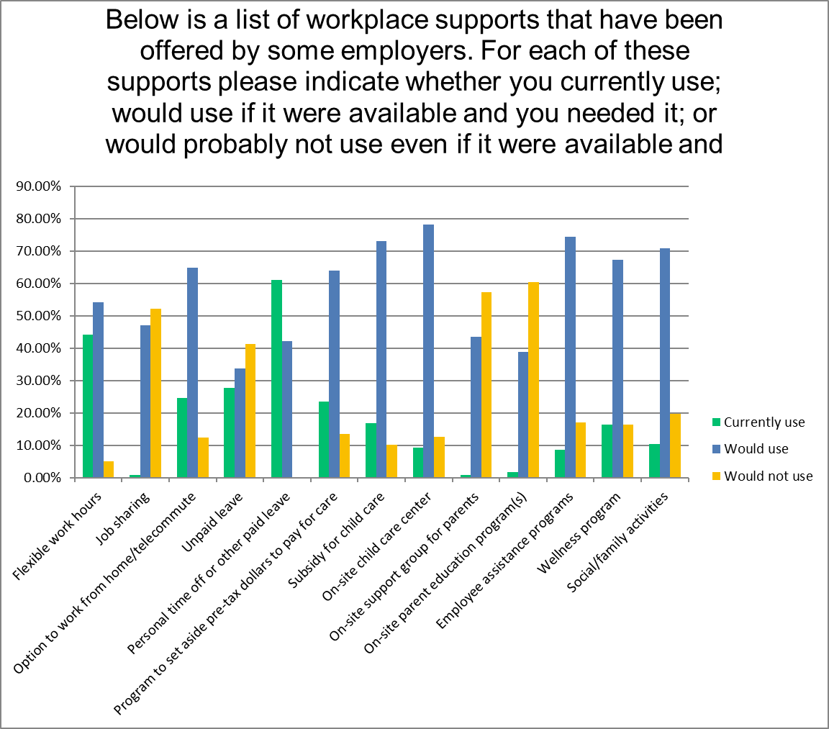
Employer Survey